SHARED RESPONSIBILITIES OF
STUDENTS, STAFF AND PARENTS

Our primary goal is to ensure the safety and well-being of all students, staff, volunteers, and guests at École St. John XXIII School. We strive to create an environment which nurtures the growth of the “whole” child; academically, emotionally, physically, socially, and spiritually. As a community of learners, the students, staff, and parents share a responsibility to create a welcoming, safe, respectful, and caring environment. It is essential that we work together to model and encourage our Christian values of love, peace, dignity, and respect.

In the process of growing up, children will occasionally make poor choices or become involved in negative situations. Our conduct policy seeks to respect the uniqueness and dignity of each child, taking into consideration such things as age, maturity, and individual circumstances, and to encourage the children to learn from their mistakes. Our goal is to treat children as individuals, and to avoid a ‘one size fits all’ approach. As partners in education, parents need to be informed of these incidents so that they too can enter into dialogue with their child/children and be positively involved in the learning process.

STUDENT RESPONSIBILITY

According to the Education Act – Section 31, a student, as partner in education, has the responsibility to:
- attend school regularly and punctually,
- be ready to learn and actively engage in and diligently pursue the student’s education,
- ensure that the student’s conduct contributes to a welcoming, caring, respectful and safe learning environment that respects diversity and fosters a sense of belonging,
- respect the rights of others in the school,
- refrain from, report and not tolerate bullying or bullying behaviour directed towards others in the school, whether or not it occurs within the school building, during the school day or by electronic means,
- comply with rules of the school and the policies of the board,
- co-operate with everyone authorized by the board to provide education programs and other services,
- be accountable to the student’s teachers and other school staff for the student’s conduct, and
- positively contribute to the student’s school and community.

In addition to these, a student should …
- take responsibility for his/her own actions/behaviour.
- demonstrate respect for self, others, and school property.
- strive to consistently make his/her best effort.
- work and play cooperatively.

Together, staff and parents should …
- provide a welcoming, safe, respectful, caring, and supportive learning environment.
- provide clear expectations and appropriate consequences for inappropriate behaviour.
- model appropriate behaviours.
- maintain a model of supportive, open, and respectful communication.
- encourage punctuality and regular attendance.
- monitor the progress of the child/children.
- review this conduct policy with the child/children to ensure understanding.

PARENT CONTACT

If a student engages in inappropriate conduct or is implicated in a significant incident, parent contact will be made by the child’s classroom teacher or by an administrator. The child’s teacher may wish to contact parents in writing, email, or phone. Should a member of the administrative team be involved in the process, communication may be made to parents.

ENCOURAGING APPROPRIATE CONDUCT

In every instance, the child will be asked to identify and assume responsibility for his/her behaviour. Oftentimes, a student will be asked to reflect upon his/her conduct in writing and to suggest steps towards improvement and growth. Parents are to ensure that their conduct contributes to a welcoming, caring, respectful and safe learning environment.

A minor offence may include items such as:
* impolite manners * inappropriate dress
* disruptive behaviour * incomplete homework
* disrespectful conduct * tardiness
* unsafe/rough play

In the case of a minor offence, the student may be asked to take time away from a given activity, work in a less distracting location, complete unfinished work, make an apology, etc. Other intervention strategies and supports may be used at the discretion of the teacher and/or administrator with both the student engaged in inappropriate behavior and students who may be impacted by inappropriate behaviors.

A major offence may include items such as:
* open opposition to authority * fighting
* wilful disobedience * vandalism
* use of inappropriate language / gestures * stealing
* habitual neglect of student responsibilities * bullying

In the case of a major offence, the student may speak with an administrator. Major offences will generally result in an in-school or out-of-school suspension as per Section 36 of the Education Act. During the suspension, the student may lose lunchroom and extra-curricular privileges and will be responsible for any work missed. The administrator will determine the length and nature of the in-school or out-of-school suspension based on the severity and/or frequency of the incident.

Bullying
Bullying is the repeated and hostile or demeaning behaviour by an individual in the school community where the behaviour is intended to cause harm, fear, or distress to one or more individuals in the school community, including psychological harm or harm to an individuals’ reputation. All students are encouraged to report incidents of bullying to a staff member.
The school’s response to bullying behaviours that occurs within or during the school day or by electronic means shall be dealt with on an individual basis.

Alberta Human Rights Act
We affirm that the rights set out in the Alberta Human Rights Act and the Canadian Charter of Rights and Freedoms are afforded to all students and staff members within St. John XXIII. We affirm that pursuant to the Alberta Human Rights Act and the Canadian Charter of Rights and Freedoms, students and staff members are protected from discrimination. The school prohibits discrimination as set out in the Alberta Human Rights Act. More specifically, discrimination refers to any conduct that serves to deny or discriminate against any person or class of persons regarding any goods, services, accommodation, or facilities that are customarily available to the public, and the denial or discrimination is based on race, religious beliefs, colour, gender, physical disability, mental disability, ancestry, place of origin, marital status, source of income, family status or sexual orientation.

The Student Conduct Policy always applies to all students, whether they occur within the school building, during the school day or by electronic means during the lunch-hour, extra-curricular activities, fieldtrips, recess, before/after school, by electronic means and while waiting for or riding the school bus.

A continuum of support will be provided to students who are impacted by inappropriate behavior as well as for students who engage in inappropriate behavior. Therefore, some examples that may occur include:

▪ Restriction of privileges and activities
▪ Parent-student conference with school staff
▪ Verbal or written apology by student
▪ Problem solving, monitoring, or reviewing behavior expectations.
▪ Replacement or repair of damaged property
▪ Temporary exclusion of student from classes
▪ In-school suspension/Out of school suspension
▪ Referral to Attendance Board
▪ Behavior contract
▪ Involvement of outside agencies
▪ Involvement of Police
▪ Expulsion
▪ Record of incident retained in PowerSchool.

École St. John XXIII Catholic School Conduct Policy

The students, parents and staff of the school must work together to create a safe and caring environment. We feel that it is important for all families and students to be appropriately informed of our Conduct Policy. For this reason, we invite you to review and discuss it as a family. To acknowledge receipt of this information, please complete the following section and return it to your child’s teacher as soon as possible.

The Student Conduct Policy is shared with all members of the school community. Each year it is reviewed by parents, students, and school staff. It is revised as per the feedback provided. The Student Conduct Policy is posted on the school website and reviewed with students on a regular basis.

Child Signature Grade

__________________ ___________________ _______

_______________________________ _______
Parent Signature Date

*Return this portion to your child’s homeroom teacher.

STUDENT CONDUCT
POLICY
2025 – 2026

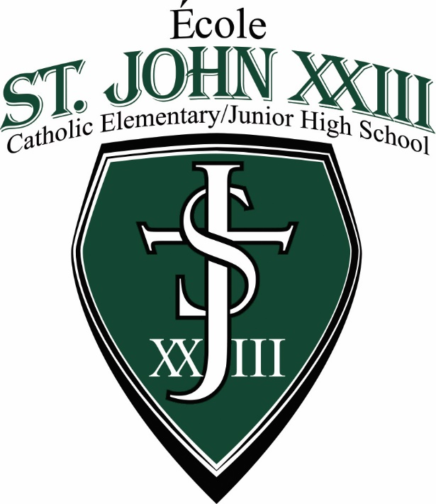

École St. John XXIII Catholic School

“Caring is everything; nothing matters but caring.”
-Baron Friedrich von Hugel

